A Reflective Service:
for worship in isolation

We come from scattered lives to meet with God.
Let us recognise God’s presence with us now.

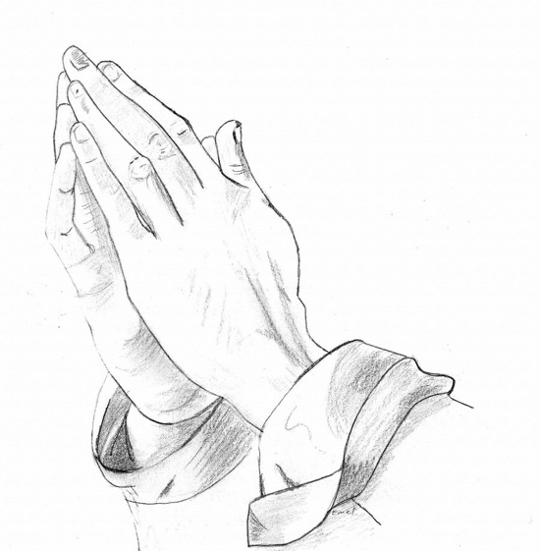
Keep a short silence, still your heart.

As God’s people we have gathered;
Let us worship God now together,
Across the miles yet joined

Let us pray.
Come, Holy Spirit,
fill the hearts of your faithful people,
and kindle in us the fire of your love;
through Jesus Christ our Lord,
Amen.

In the light of Jesus, let us examine ourselves
and confess our sins.

Keep a short silence, leave your sins at the cross

Confession: Father, we have sinned against heaven and against you.
We are not worthy to be called your children.
We turn to you again, have mercy on us,
bring us back to yourself as those who once were dead
but now have life through Christ our Lord.
Amen.

Absolution: May the Father forgive us by the death of the Son,
and strengthen us to live in the power of The Spirit
all our days. Amen.

Find the bible reading for today on the church website
Along with a short reflection for you to read.

We affirm our faith in Jesus Christ the Son of God:

Though he was divine, he did not cling to equality with God,
but made himself nothing. Taking the form of a slave,
he was born in human likeness. He humbled himself
and was obedient to death, even the death of the cross.
Therefore God has raised him on high,
and given him the name above every name: that at the name of Jesus
every knee should bow, and every voice proclaim
that Jesus Christ is Lord, to the glory of God the Father.
Amen. cf Philippians 2.6-11

We intercede for others in the quiet of our hearts.
Lord, meet us in the silence
And hear our prayer.

Silence for prayer is kept:
Pray for yourself in your isolation, that God would sit with you
Pray for others in their loneliness
Pray for our country
Pray for the world
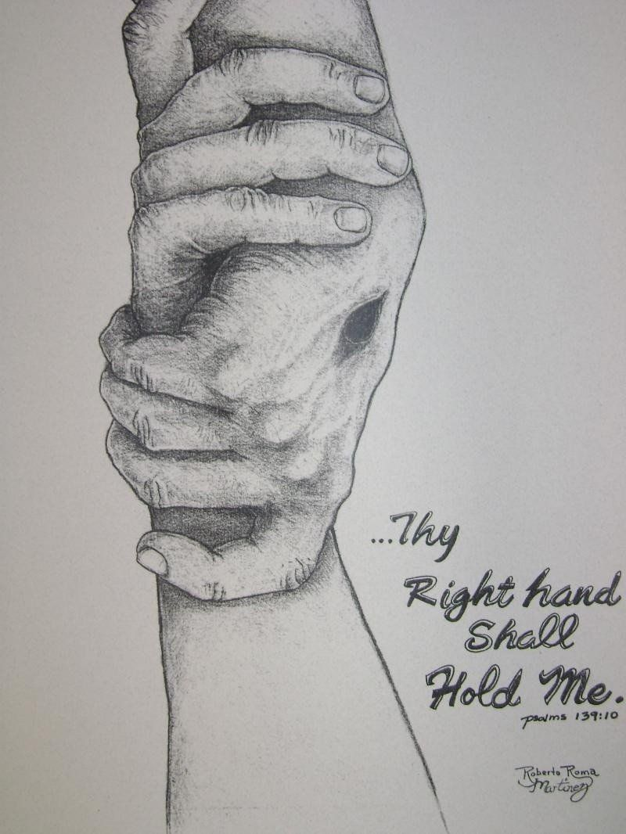
Our Father, who art in heaven,
hallowed be thy name;
thy kingdom come;
thy will be done;
on earth as it is in heaven.
Give us this day our daily bread.
And forgive us our trespasses,
as we forgive those who trespass against us.
And lead us not into temptation;
but deliver us from evil.
For thine is the kingdom,
the power and the glory,
for ever and ever.
Amen.

Silence is kept

Faithful God, may we who have shares in this time of worship
Glory in the cross of our Lord Jesus Christ,
Our salvation and hope, Who reigns as Lord now and forever.

Fill us, Good Lord with your Spirit of love;
And as you have fed us with your presence,
so make us one in heart and mind,
In Jesus Christ our Lord.
Amen.

Let us bless the Lord
Thanks be to God.

If you want to live out your faith in your isolation,
why not telephone someone, to let them know that they are not alone.

If you are lonely, telephone Revd Annette 0208 850 0374 , 07570715525

“For God has said, ‘I will not leave you or forsake you’ so we can confidently say, ‘The Lord is my helper; I will not fear’.” (Hebrews 13:5-6)

“It is the Lord who goes before you. He will be with you; he will not leave you or forsake you. Do not be dismayed.” (Deuteronomy 31:8)

Please God, we can meet together in church again, soon.

